**Question 1:** Write down some different kinds of cloud computing applications that are not in google.

Some cloud computing applications are Xbox cloud gaming, Nvidia GeForce Now, Apple iCloud, Playstation share play etc.

**Question 2:**

i) mkdir - this command adds a new folder/directory to the current file path.



ii) ls - this command will show a list of all the files in the current directory



iii) cd - this command changes the current directory to the new directory, it can also be used to go back to the previous directory using “cd ..”



iv) rmdir - this command removes the directory from the current file path.



v) df - this command provides a detailed description of the disk space used by different file systems.

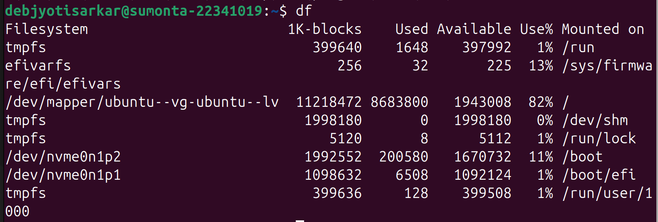

vi) cp - this command is used to copy files from the current directory to a new one.



vii) mv - this command is used to move files from the current directory to a new one.



viii) touch - this command creates a new file in the current directory.



ix) cat - this command can display the texts of one file or concatenate texts from multiple files and display them in the terminal.



x) apt-get update - this command will update all the current packages in the local repository

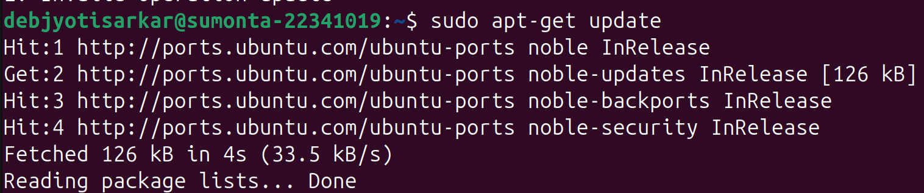

xi) apt-get upgrade - this command will check if there is any new versions available in the local repository and if there is, it will upgrade it

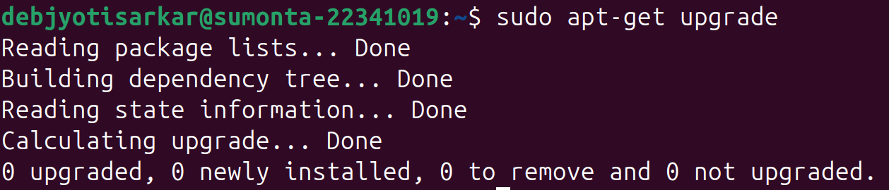

xii) date - this is used to fetch the current date

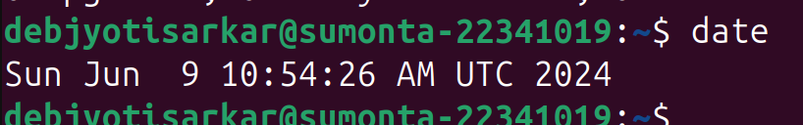

xiii) top - this shows all the resources currently being used in an descending order.

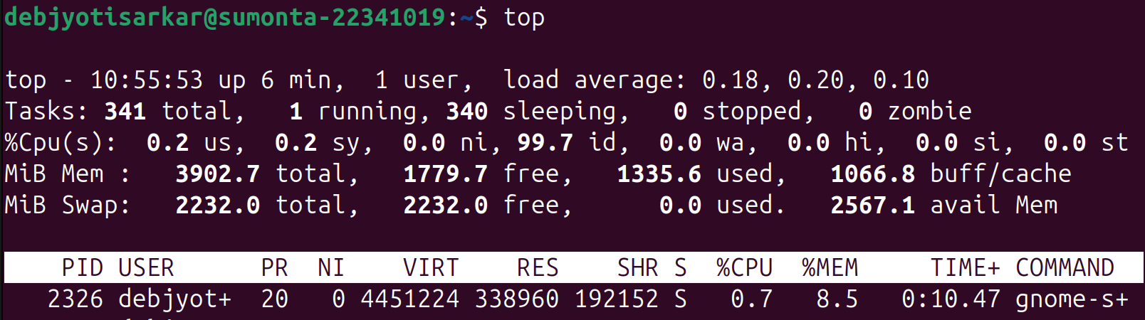

xiv) clear - this command is used to remove all the previous lines of the terminal



xv) rm - this command is used to remove a file from the current directory



xvi) nano - this command opens up a text editor inside the terminal

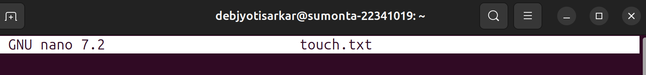

xvii) history - this command retrieves all the commands ran on the terminal

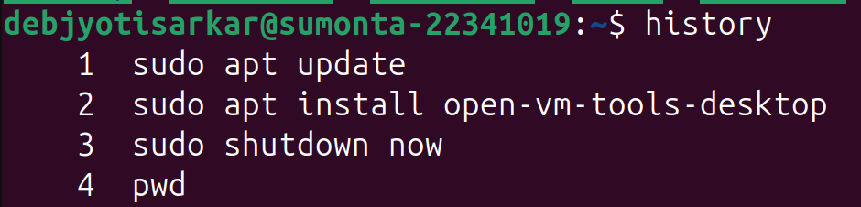

xviii) help -

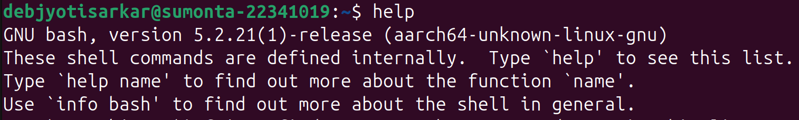

xix) exit - this command is used to exit the terminal



xx) shutdown - this command is used to shutdown the system, by default it shuts down after a certain period of time; the now extension shuts down the system instantly



xxi) reboot - this command is used to reboot the system, by default it reboots after a certain period of time; the now extension reboots the system instantly

